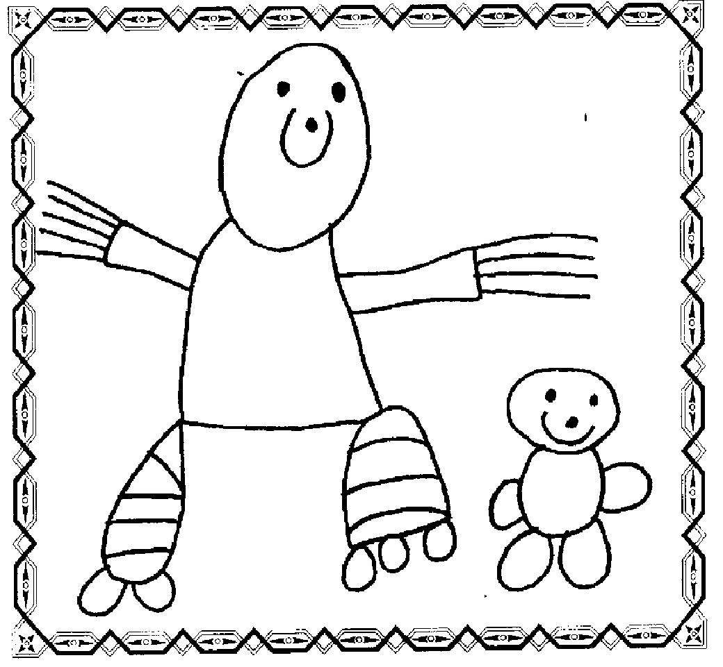
Tremorfa Nursery School Tremorfa Afternoon Club & Flying Start
Confidentiality Policy and Data protection
During the course of the day, the setting will come into contact with confidential information. To ensure that all those using and working in the setting can do so with confidence, we will respect confidentiality in the following ways.
- Parents/carers will have access to files and records of their own children but not any other child.
- Staff will not discuss individual children with people other than the parents/carers of that child or a health visitor if the parent/ carer has signed consent as part of the nursery entry forms.
- Information given by parents/carers to nursery staff will not be passed on to third parties.
- Personnel issues will remain confidential to the people involved.
- Any anxieties/evidence relating to a child’s personal safety will be kept in a confidential file and will only be shared with staff within the club and nursery on a ‘need to know’ basis where this will be in protection of the child.
- The nursery and club will comply with all requirements of the Data Protection Act and in conjunction with the Information Commissioners Office ( see school data protection policy)
- Staff may see or hear information regarding a child, this information should not be divulged outside of the setting.
- Children’s individual abilities and behaviour should not be discussed with anyone other than the parent unless it involves another child.
Any staff member found to be discussing individual children with anyone other than for the purpose of curriculum planning or nursery management or child protection with people other than the parents or carers of the child will be asked immediately to report to the Nursery School Headteacher where disciplinary conversations and / or procedures will take place in line with the school and council policies.
Information given by parents or carers to the nursery will not be passed on to other adults without permission except in exceptional circumstance when the safety of the child or staff is at risk.
Issues relating to staff employment, sickness and absences whether paid or unpaid, will remain confidential to the people directly involved with personnel issues.
Anxieties or evidence relating to the child’s welfare will be shared with other professionals on a ‘need to know’ basis only and will not be open for discussion amongst staff in general terms.
Although we cannot always promise not to pass on information (especially if we believe the child to be in danger) we will do so in a manner totally appropriate and essential for the wellbeing of the child and in consideration of those involved
Some parents/carers sometimes share information about themselves with other parents/carers as well as staff, the nursery cannot be responsible if information shared beyond those parents/carers whom the person has ‘confided’ in.
If parents are experiencing difficulties, the nursery Headteacher and club manager is available and may be able to offer guidance on where to go for help or advice.
Records about individual children including accidents/incident records, must be retained for a period of at least three years after the last date on which the children attended. The requirements of a registered person’s insurance may require that records are retained for longer.
All paper records are disposed of through shredding inhouse or through Elite Paper Solutions. Digital records are disposed of through the schools Service level agreement with Cardiff Council, delivered by ITeach.
Tremorfa Afternoon Club use the online learning platform Seesaw to document the learning and experiences of the children in the service. The app uses security and encryption best practises. Written consent is obtained through the nursery admission forms prior to a child attending Tremorfa Afternoon Club. Parents can only access and view their own child’s platform. All level 2 and above playworkers are responsible for posting on children’s Seesaw platforms. A list of children that do not have permission to be on Seesaw is regularly updates and given to staff.
Tremorfa Nursery School uses a closed Facebook and Instagram page. Parental consent is sought for any photo of a child on the social media accounts. No children’s names are used on social media.

Tremorfa Afternoon Club does not use any other form of social media.

In accordance with the:
The Children’s Act 1989, The Data Protection Act 1998, Human Rights Act 1998

