Tremorfa Nursery School
Strategic Equality Plan
2023 – 2026

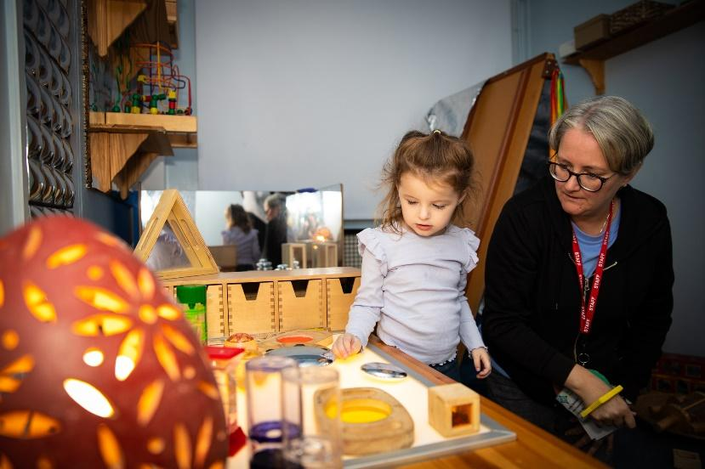



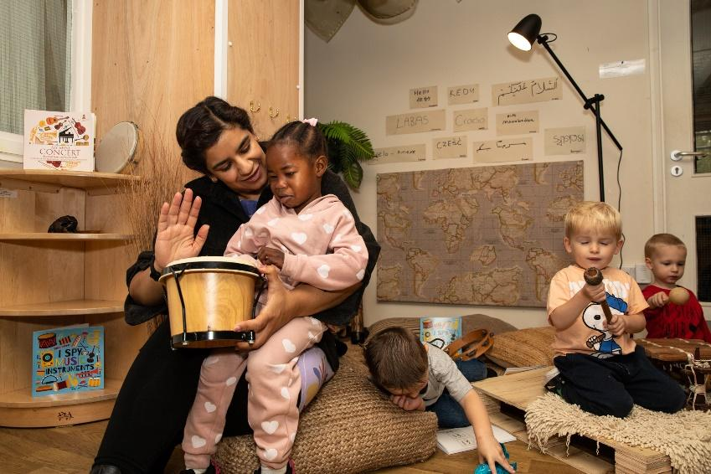

Contents of our Strategic Equality Plan (SEP)

Our school 3
Aims 4
Objectives and Action Plans 4
Scope 5
Equality Summary Statement 5
Responsibilities 6
Information gathering and Engagement 7
Publication and reporting 8
Monitor and Review 8
School Equality Objectives and Action Plan 9

Strategic Equality Plan Policy Statement

- Our School

Tremorfa Nursery School is a Local Authority maintained nursery school with 60 FTE (120 part time) pupils. Our school is situated on the south eastern outskirts of the city of Cardiff and mainly serves the community of Tremorfa. is classed as an area of significant social and economic deprivation and has been designated as a Communities First area. The majority of families live close to the school with a minority travelling from other areas of Cardiff (largely on the grounds of the school’s reputation foe inclusive practice). The majority of families live in accommodation rented from the council of housing association. On entry to nursery appropriately 65% of children are admitted with delayed speech, language and communication skills. There are 6% of children on a child protection of care and support plan.
It has 18 teaching and non-teaching staff. At present 8% are EAL children and 18% are on the ALN Register.

The school has a transient population, this fluctuates year on year. This is partly due to the number of new arrivals and families being rehoused, who do not always remain in the locality for long.

Pupils are from a range of ethnic backgrounds, including: 70% White British, 6% Nigerian, 2% Arab, 2% white and Black African, 2% other Black, 2% Asian and Black, 4% White and other ethnic group, 2% other White, 2% White and Asian, 4% Indian, 2% Traveller of Irish Heritage and 2% Info refused.

Different Religions or Beliefs represented in our school include: Christianity, Muslim, Sikhism, Hinduism, Buddhist, as well as Agnostics, Atheists and Humanists.

There are 4 different languages spoken by our pupils as their first language including: English, Arabic, Polish and Tamil.

We have pupils with a range of additional learning needs. We are fully inclusive of all pupils and meet the needs of all our learners. Working with both outside agencies and outreach programmes, as well as our ALNCo and Nominated adults.

We comply with the Local Authority Online Recruitment Policy and Procedure which now monitors Sexual Orientation of staff. We are aware that we have parents in same sex relationships however we do not monitor this robustly. We are also aware that in every group, there will be pupils who will grow to be LGBT.

All of these people, their faiths, cultures, communities and languages are valued equally and respectfully at Tremorfa Nursery School.

2. Aims

We recognise and celebrate the fact that British and Welsh society is made up of people from diverse backgrounds and life experiences. It is important that all pupils are prepared to live in such a society. The purpose of our Strategic Equality Plan (SEP) is to fulfil the duties to promote equality for people with ‘protected characteristics’, and embed fairness and equality at the heart of our school community and in all aspects of our school plans and policies.

Through the equality improvement actions and strategically planned tasks detailed in this document, we aim to:

- Eliminate discrimination, harassment and victimisation
- Advance equality of opportunity between persons who share a relevant protected characteristic and persons who do not share it
- Foster good relations between persons who share a relevant protected characteristic and persons who do not share it

We have based our Strategic Equality Objectives on local, regional and national priorities within Education as well as feedback from engagement with our school community and our own school data. These actions are set out in Section Ten.

3. Our Strategic Equality Objectives

Our chosen Strategic Equality Objectives are

1. Reduce Gaps in attainment and attendance between children from protected groups
2. Develop the quality and use of our Equality Information
3. Teach our children, staff and governors about the principles and practice of equality, diversity and anti-discrimination

We have strategically planned tasks to enable us to meet these objectives. They are listed in Section Ten of this Strategic Equality Plan (Action Plan). They cover all relevant protected characteristics. They describe how we are taking action to fulfil both the general and specific duties.

- Scope

The policy applies to all full time, part time, job share, permanent, temporary and supply staff. It applies to all pupils, parents, service users and visitors to the school in line with Equality legislation and the school’s legal responsibilities to promote equality in employment, education and access to services.

5. Equalities Summary Statement

At Tremorfa Nursery School we aim to provide a happy, caring environment in which all children can feel confident and able to learn. We seek to foster an environment of mutual respect and support between all staff, children, parents and carers and the wider community.

Our school is committed to eliminating any unlawful discrimination on grounds of Race, Gender, Transgender, Religion or Belief, Disability or Sexual Orientation, Pregnancy or Maternity Marriage or Civil Partnership by creating an environment where every individual, regardless of ability or background, is able to participate and is valued fully as a member of the school community. Being opposed to all forms of discrimination and prejudice we promote a positive attitude towards differences and expect respect for people of all backgrounds. This is highlighted in our whole school rules, with our first rule being: “We respect everyone and everything”.

Stereotyped ways of thinking are the result of ignorance and may result in low self-esteem and limited aspirations. The school values and encourages involvement of people from all sections of the local community and through this involvement aims to provide positive images, which challenge stereotyped thinking.

Any language or behaviour which is racist, sexist, homophobic, disablist or potentially damaging to any group will not be tolerated and will be challenged and monitored. Information derived from monitoring will be used to plan whole-school strategies to combat incidents. Information on identity based incidents and bullying will be shared regularly with the LEA to help actions to combat hate crime across the City.

6. Responsibilities

Leadership and Management

Commitment
The Governing Body and management of the school will work with all its partners to be proactive in promoting equal opportunities, fostering good relations and in tackling unlawful discrimination. They will encourage support and enable all pupils and staff from all protected characteristics to reach the highest standards possible.

Headteacher
The Headteacher is responsible for:

- Making sure the Equality Policy is readily available, along with related policies as laid out in the HR Manual for Schools and other school policies.
- Ensuring that governors, staff, children, parents and guardians know about it.
- Making sure the policy and its procedures are followed.
- Producing regular information for staff and governors about how the policy is working, and providing training for them on the policy if necessary.
- Making sure all staff know their responsibilities and receive training and support in carrying these out.
- Taking appropriate action in cases of harassment and discrimination.
- Making sure the Equality Policy is regularly monitored and reviewed.

The named person with responsibility for dealing with reported incidents of unlawful discrimination is the Headteacher, Samantha Jones. Staff and children are aware of who the named person is. The named person ensures that all reported incidents are recorded in the Equality Incident and Monitoring Database, analysed within the school and sent to the LEA termly.

The Equal Opportunities Co-ordinators are Samantha Jones (Headteacher) and Sally Angell-Fox (ALNCo Senior Teacher). The Equal Opportunities Co-ordinators ensures that the school regularly reviews and evaluates all policies and practices in relation to Equal Opportunities, leading to the setting of targets which address aspects of inequality or disadvantage in all of the school’s activities.

All staff are responsible for:
- Dealing with incidents of unlawful discrimination and bullying
- Being able to recognise and tackle bias and stereotyping
- Promoting equality and good relations between all groups
- Keeping up to date with the law on discrimination, and taking up training opportunities
Striving to provide images and lesson plans that show positive images of and are inclusive of people from the protected characteristics.

7. Information gathering and Engagement

The collection of information is crucial to supporting us in deciding what actions to take to improve equality and eliminate discrimination within the school community. The information also subsequently helps us to review our performance, so it needs to be detailed enough to enable us to measure how we are delivering on equality duties. The information also helps us to do accurate impact assessments and identify which of the school’s aims have been achieved and what we need to do better.

Engagement is based on the information gained about representation of different groups. We aim to do this as fully as possible. The reason that this progress is important is to understand the full range of needs of the school community.

We have various processes in school to allow parents and staff to feed back and inform the Nursery of any equality issues or priorities for development and we collect this information through Parent Questionnaires, Parents evenings, Parental Comments Box, Staff Performance etc. Due to the diversity present in our pupil, staff and parent groups we therefore have a readily available and easily accessible group of people for the purposes of engagement on equality priorities generally and this Strategic Equality Plan specifically.

8. Publication and reporting

The school publishes the Strategic Equality Plan on our website and is communicated to parents at parents evening and other events. It is available in large print and other formats on request. The school prospectus includes a reference to the Strategic Equality Plan and the values underpinning it.

We will report and publish annually on the progress made on the action plans and the impact of the Plan itself on school ethos and practice within the school. This is undertaken as part of the Governors’ Annual Report.

9. Monitor and Review

We will revisit and analyse the information and data used to identify priorities for the Strategic Equality Plan (e.g. achievement data, engagement with stakeholders).

We will use Equality Impact Assessments to ensure that actions taken have a positive impact across all protected characteristics, that the promotion of equality is at the heart of school planning and that discrimination is being eliminated effectively.

Based on the above, we will review the Plan and republish as necessary, but not less that annually with a full review not less that four yearly.
10. Strategic Equality Action Plan
2023-26

Priority One: Reduce Gaps in attainment and attendance between pupils from protected groups
Targets:
- To record and monitor involvement levels and access of provision by children with additional needs.
- To improve the literacy skills of children with English as an additional language.
- To highlight the importance of attendance to all groups of learners and their families.

Success Criteria
- EEL observations and data collected and analysed on the basis of gender, EAL, BM, Race and Disability
- To ensure all families receive ‘Miss School, Miss Out’ handbook during admission process and letters and other information are translated and accessible for all.
Strategically Planned Tasks:  - The ‘Observer’ adult within our rota will carry out observations daily and have specific groups of learners to focus on. Ensure all protected groups are tracked and monitored.  - Audit of continuous provision areas and the resources available to look at resourcing and access.  - Look at the information given to families during the admission process and ensure there is clarity amongst all the relevant information.  - Staff to be kept up to date on the Equality Policy and procedures and the specific protected groups within our setting. |  | On Track | Lead Person(s) Involved  All staff  All staff  SJ/SA  SJ | Time Scale  Termly  Autumn Term 2024 (annually)  Termly  Annually
Monitoring Commentary (Bullet Points) | Evaluation Commentary (Bullet Points)

Priority Two: Develop the quality and use of our Equality Information

Targets:

  - To make some amendments to our enrolment form to better collect useful equality information on parents
  - Review equality monitoring at recruitment and selection stage of staff and governors
  - Governing body to report termly on attendance by protected characteristics
  - Identify gaps in equality information currently
  - Equality Impact Assess all policies due for review during (the lifecycle of this Strategic Equality Plan)

Success Criteria
- To collect and monitor the equality data of staff and governors.
- To access and monitor all race related incidents as and when necessary.
- Governing body meeting to have a focus on the agenda (termly) to focus on and highlight attendance
- SA to monitor and identify any gaps in equality information within the school.
- To highlight policies within the school’s Strategic Equality Plan.
Strategically Planned Tasks:  - To look at the opportunity for equality information of parents to be expressed during the admission process.  - Gather all relevant information for staff and governors.  - Monitor any race related incidents and ensure all staff are aware of the process in place.  - Chair of governors to place an emphasis on Attendance during termly meetings, in order to highlight and address any areas for improvement and to ensure all governors have a grasp on this area.  - To train Staff/Governors in Equality, Identity Based Incidents and Equality Impact Assessments. |  | On Track | Lead Person(s) Involved  SA  SJ/SA  SJ  SJ  SJ | Time Scale  Spring 2024  Summer 2025  Termly  Termly  As and when necessary
Monitoring Commentary (Bullet Points) | Evaluation Commentary (Bullet Points)

Priority Three: Teach pupils, staff and governors about the principles and practice of equality, diversity and anti-discrimination

Targets:

  - The whole school community is, and continues to be, committed to the ideal of equality for all
  - Staff and governors are aware of their statutory obligations under the Equality Act
  - Staff and governors are fully signed up to the principles of equality and diversity as agents of the school
  - Staff and governor training combines basic training for all staff with specialist training for selected staff dependant on priorities and emerging equality issues or trends
  - The curriculum reflects a fully inclusive approach for all learners and there is evidence of planned teaching of equality and diversity.
  - To continue to timetable Language focused groups e.g. ICAN, WELLCOM in to our continuous provision

Success Criteria
- All stakeholders to be fully inclusive and committed to a school community of equality
- All staff and governors aware of their roles and responsibilities in accordance to legislations.
- Staff and governors act as positive role models and have inclusion at the heart of their practice.
- Staff and governors to be kept up to date and to have opportunities to access appropriate and relevant training.
- To continue to plan effectively to meets the needs of all learners.
Strategically Planned Tasks:  - To organise events to embrace the diversity of the community e.g Coffee Mornings, Dads, Lads and Grandad’s Day.  - Celebrate festivals and occasion days that are relevant to the children within the school and plan whole school activities around these particular celebrations.  - Language focused groups to be monitored and appropriate objectives set out for the learners.  - Governors to be informed of such events and included. Termly feedback and evaluations for all stakeholders.  - Specific training to be available for Staff, SLT team and Governors. |  | On Track | Lead Person(s) Involved  SJ/SA  All Staff  SJ  SJ | Time Scale  Termly  Termly  Termly  As and when necessary
Monitoring Commentary (Bullet Points) | Evaluation Commentary (Bullet Points)

Reviewed: September 25
S.Jones

