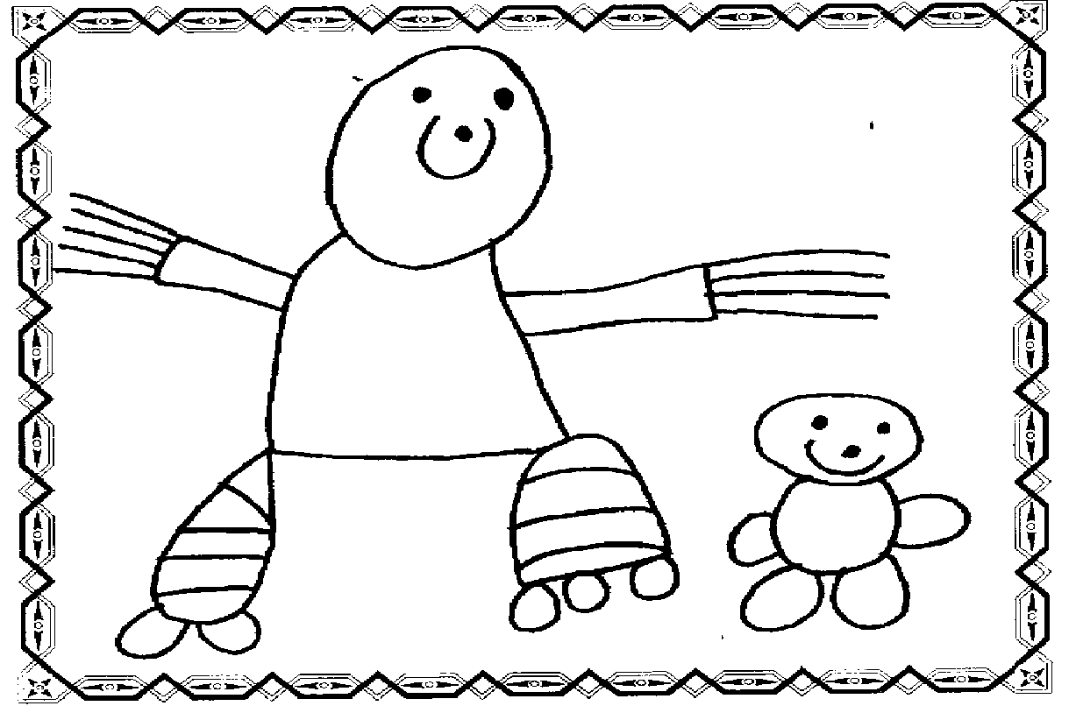

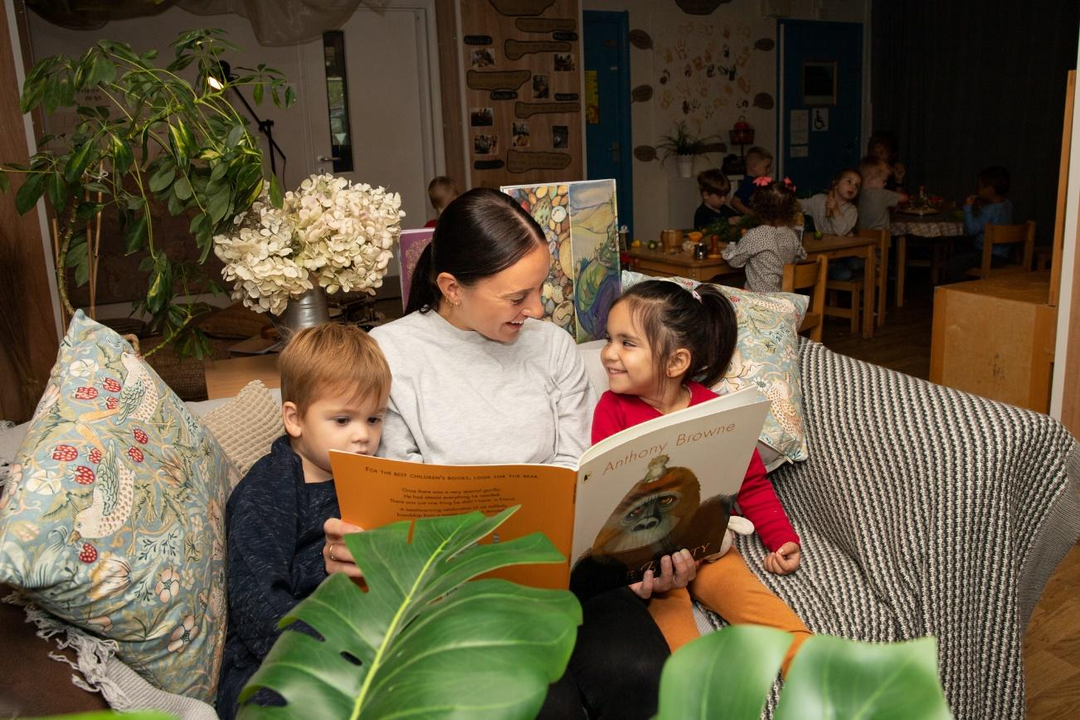

Tremorfa Nursery School
Relationship and Sex Education Policy

Relationships and Sexuality Education (RSE)
Statement of Intent

Tremorfa Nursery School seeks to ensure that all its children receive part time Nursery education and wrap-around care in a safe, happy and inclusive environment.

The nursery school strives to provide a welcoming, caring environment, whereby each member of the nursery community feels valued, safe and secure.

All staff work in an open and honest manner with young children and their families to ensure that each child feels able to speak to a member of staff about any issue they wish to raise.
RSE
Relationships and Sexuality Education (RSE) involves the delivery of lessons that aim to prepare all pupils for the opportunities, responsibilities and experiences of adult life, taking note of their moral, spiritual, cultural, mental and physical development at school and in the world.
At Tremorfa Nursery School RSE will be delivered incidentally within the curriculum ethos through play, stories, group times and open discussions. Staff will reflect regularly on phase 1 of the RSE code to ensure activities and experiences provide early exploration of this phase. As element 1 is designed for 3-7 years olds and children at the nursery are aged 4 and under, staff will ensure coverage is appropriate to the age and stage of the children. However staff will not shy away from discussion when instigated by a child or as a need or experience arises.
Introduction
This policy has been developed in line with guidance from the Welsh Assembly Government Circular No. 019/2010 (Sex and Relationships Education in Schools). Several other documents were also used to support the writing of this policy, including:
- The Sexual Health and Wellbeing in Wales Action Plan, 2010–2015 Education Act 1996
- AoLE for Health and Wellbeing
- EAS RSE toolkit
- Curriculum for funded non maintained nursery settings
Links with other Policies and Curriculum Areas
- Confidentiality
- Safeguarding/child protection
- Anti-bullying and Hate Crime
- Relationships and Wellbeing
- Equality and diversity.

Background
From September 2022 the school will be implementing a new approach to relationships education. We are basing our approach on Welsh Government guidance and principles that we have agreed in our local cluster of schools.
Relationships and Sexuality Education covers many different topics, all of which overlap with other areas of learning and experience from the Curriculum for Wales. The guidance covers three strands of learning:
-relationship and identity
- sexual health and wellbeing
-empathy, safety and respect

Cluster Aims

As a cluster of schools in the area we have worked collaboratively to develop a shared set of aims for all children. These aims are:

- To ensure that the information that we are sharing with children is factually correct and respectful of cultural and faith differences
- To ensure children know how to treat each other respectfully
- To help prepare our older children for the changes in their own bodies and emotions as they get older
- To ensure that children understand their right to be safe from harm
- To help children to understand that we all have different needs yet we all have the same rights

Rationale
The Welsh Assembly Government’s seven core aims describe the entitlement of children and young people to access educational and health services. Effective school RSE programmes help learners to develop the skills and knowledge appropriate to their age, understanding and development. Learners are enabled to make responsible decisions about their relationships, sexual health and well being.
Schools are recognised as playing an important role in having a positive and sustained impact on children and young people’s sexual health and well-being. All learners need help to build up their confidence, awareness and self-esteem, which will in turn assist them in managing and negotiating their personal relationships as they develop.
RSE is about understanding the importance of stable and loving personal relationships, respect, care, and the building of successful relationships with friendship groups and the wider community. We live in a diverse society and pupils come from a variety of family backgrounds.
‘’Teachers should take care to approach all pupils with sensitivity and respect and ensure that there is no stigmatization of pupils based on their home circumstances’’.
(Sex and Relationships Education in Schools, Circular 019/2010, WAG 2010)
Tremorfa Nursery School is committed to supporting and developing children’s understanding of Relationships, Sexuality Education (RSE). It will be approached in a developmentally appropriate way as part of the Health and Wellbeing Area of Learning and Experience and the ‘Belonging’ Developmental Pathway with areas of overlap into the Science and Technology AOLE with some aspects of the Humanities AOLE.
Aims
At Tremorfa Nursery School we aim to develop age appropriate RSE in the context of a broad and balanced curriculum. At the end of their time at nursery the children should be able to:
● value themselves
● recognise and communicate their feelings (in a developmentally appropriate way which may include visuals)
● form friendships and relationships
- Understand when something is not theirs to take and begin to understand the importance of sharing and turn taking with consent
- Demonstrate an understanding of kindness towards others

The children will be beginning to develop and understanding of the following (as appropriate to their development:
- the difference between appropriate and inappropriate touch.
- The difference between the male and female body

The content of the curriculum includes:
- Learning about the Life Cycle
- Helping children safe by helping them to recognise and respond appropriately to unacceptable behaviour by adults and other children
- Learning about healthy relationships including kind and mutual friendships

Providing information on:
- Healthy relationships
- Names for parts of the body (when children ask questions)
- Appropriate and inappropriate touching
- Different kinds of families
- Helping children to adapt to changes within the family
- Helping children to understand their own feelings and the feelings of others
- Teaching children to respect themselves and other people through stories and role play

The delivery of the RSE programme
As with all curriculum areas RSE will be delivered through inquiry based learning and learning through play, stories and exploration.
Phase 1 will be carefully planned into inquiries and where appropriate structured but spontaneous questions and issues will be dealt with by the adults giving as much detail as they feel is necessary.
Some elements of Phase 1 might be planned for using a more teacher directed approach as part of a family group time.
Confidentiality
As a general rule, a child’s or parent’s confidentiality will be maintained by the teacher or member of staff concerned. However, the staff and volunteers are fully aware of confidentiality issues if a child divulges that they are or have been abused. A child may only feel confident to confide in a member of staff if they feel that the information will not be divulged to anyone else. However, all staff have a professional responsibility to share relevant information about the protection of children with the designated statutory agencies when a child is experiencing child welfare concerns.
It is important that each member of staff deals with this sensitively and explains to the child that they must inform the appropriate people who can help the child, but they will only tell those who need to know in order to be able to help.
Equality Statement
Tremorfa Nursery School is open to everyone. We will not discriminate in providing education and access to any benefit, service or facility either directly or indirectly, against anyone with a protected characteristic.
We will not discriminate on the grounds of:
⮚ disability
⮚ gender reassignment
⮚ marriage and civil partnership
⮚ pregnancy and maternity
⮚ race
⮚ religion or belief
⮚ sex
⮚ sexual orientation
⮚ the Welsh language in Wales.
Age is a further protected characteristic. In a school context it applies to everybody except pupils.
It is important that all parties are aware of equal opportunities for males and females and that race and cultural beliefs are duly considered. All materials used must be carefully checked for this and all visitors and outside agencies must be informed of the school’s policies.
Working with parents/carers and the wider community
This policy is available to parents/carers via the school website. A paper copy is available from the Headteacher.
Monitoring and evaluation
The Headteacher, Senior Leadership Team and Health and Wellbeing Lead are responsible for monitoring standards of learning and teaching in RSE. Learners will be asked to contribute to the evaluation of the RSE programme through feedback questionnaires and discussions, which will in turn feed into whole school self -evaluation.
Phase 1 can be found by following the link below. Staff from Tremorfa Nursery School and the two Cardiff nursery schools are collaboration on a shared document to provide developmentally appropriate experiences to meet some elements of phase 1 at nursery school level.
https://hwb.gov.wales/api/storage/a25c8a68-6ec7-4e8c-a33d-12e22bca7fea/3-empowerment-safety-and-respect-strand-mandatory-content.pdf
Reviewed: September 2025
S. Jones

